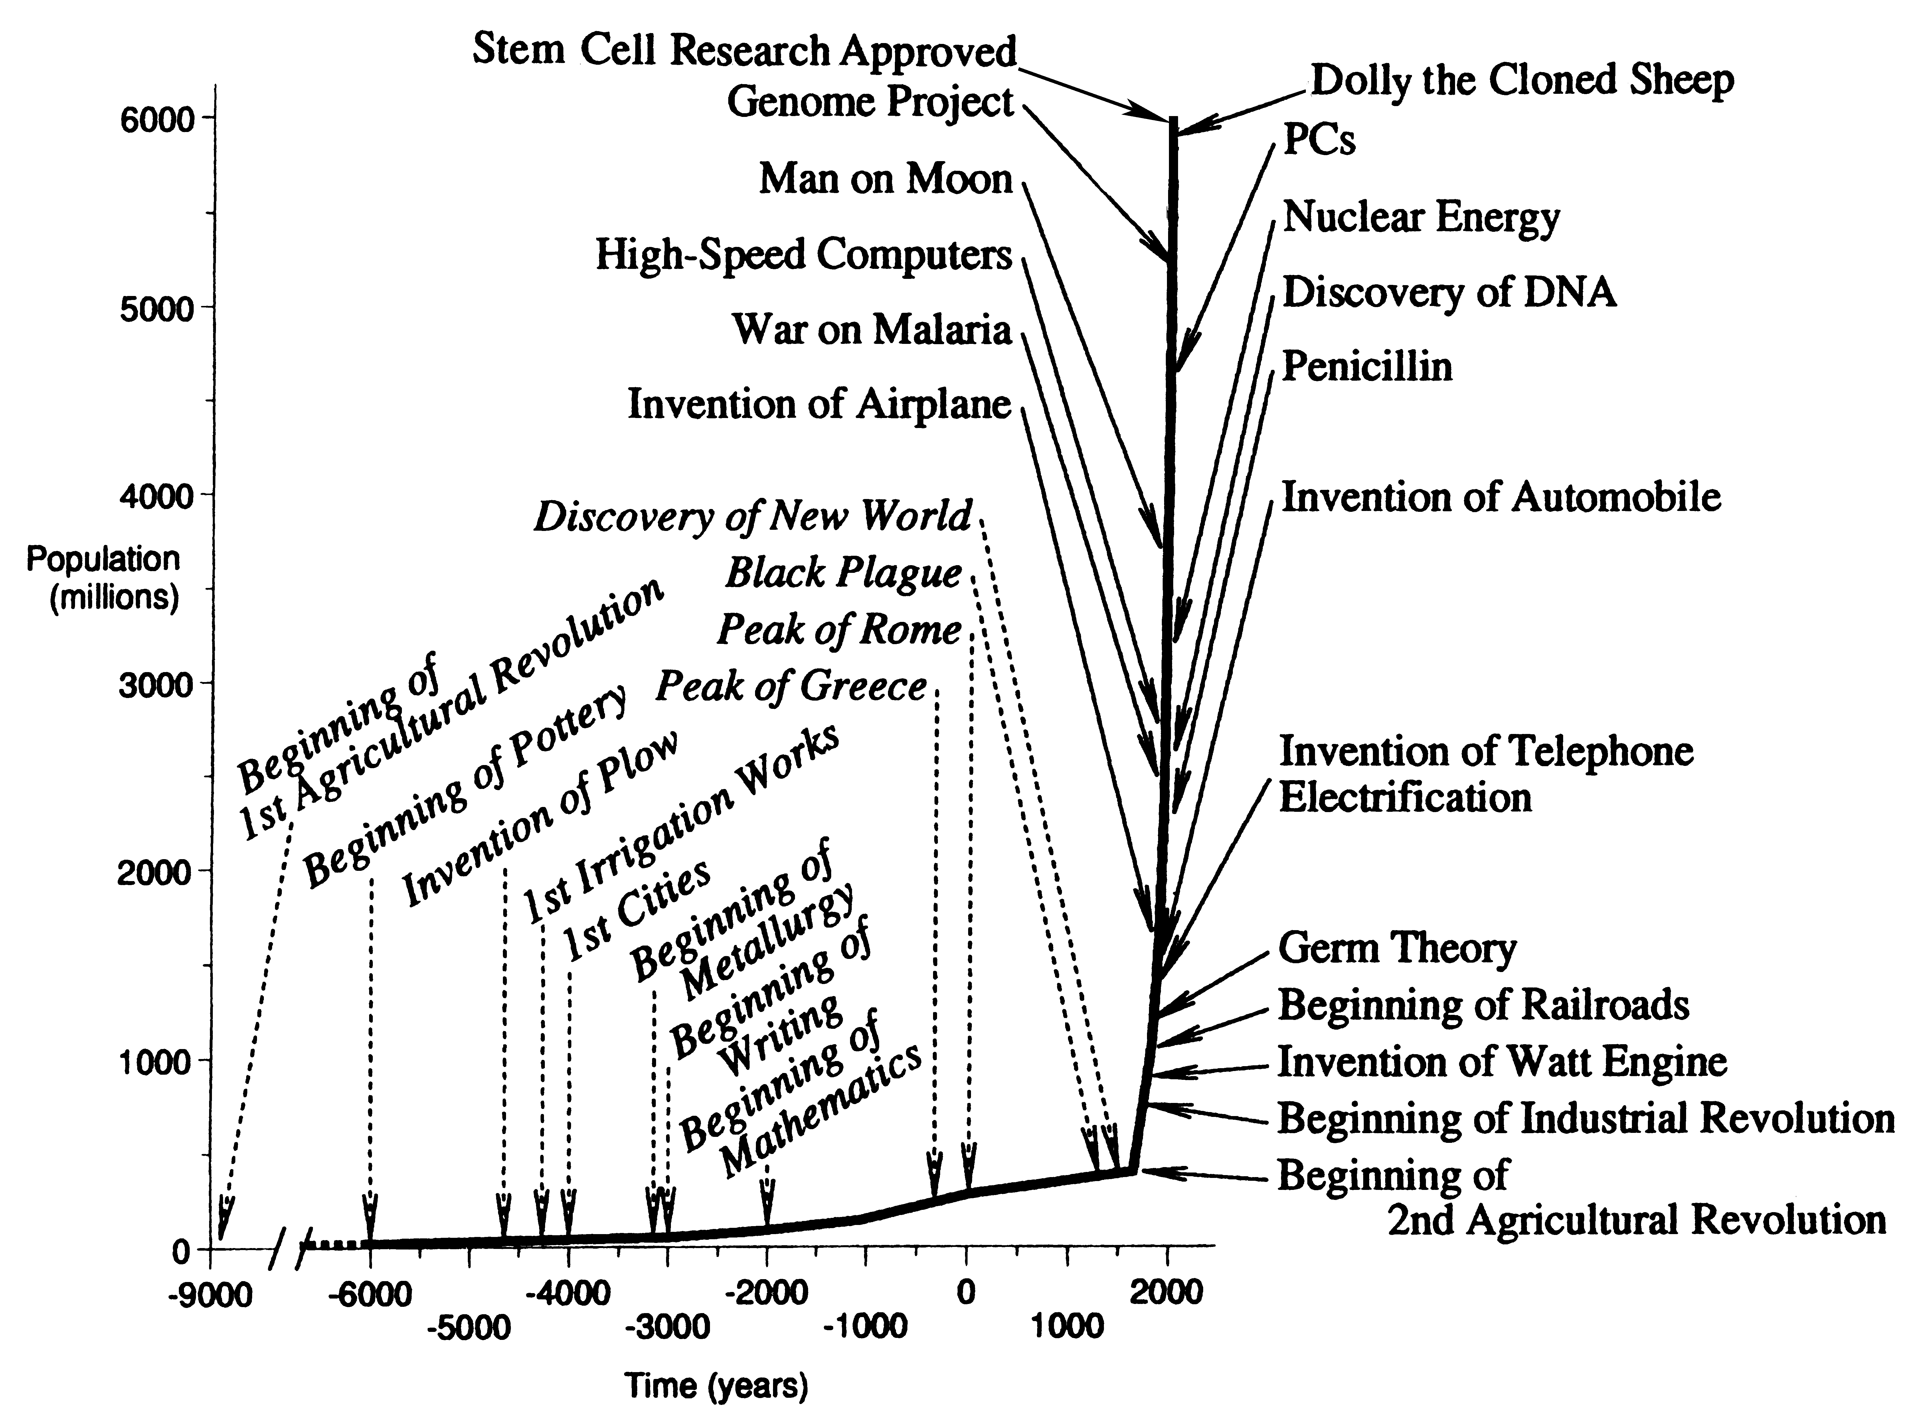

Figure 1. The Growth of World Population and Some Major Events in the History of Technology

Sources: Cipolla 1974; Clark 1961; Fagan 1977; McNeill 1971; Piggott 1965; Derry and Williams 1960; Trewartha 1969. See also Allen 1992, 1994; Slicher von Bath 1963 and Wrigley 1987.

Note: There is usually a lag between the invention (I) of a process or a machine and its general application to production. “Beginning” (B) usually means the earliest stage of this diffusion process.

